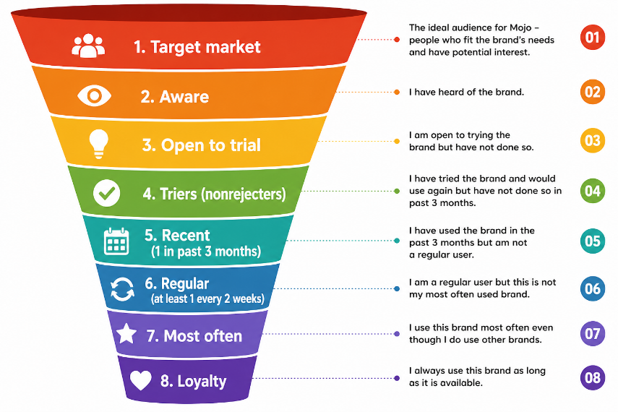
My Experience with Mojo
Figure 1: Marketing Funnel
- Target Market
As a regular soft drink consumer, I used to prefer global brands like Coca-Cola. Price sensitivity and social awareness (Isreal incident) started influencing my choices more over time. As a student affordability and ethics both mattered. That positioned me perfectly within Mojo’s target audience.
- Aware
I was already aware of Mojo as a local alternative for years. I had seen it in shops and ads, but never paid serious attention. It was always there in the background, just not my preference. Coca-Cola dominated my mind at that stage.
- Open to Trial
Things began to change as Coca-Cola was dominating the soft drinks market, they tried to increase their price in all their products. Also, the news of being associated with Isreal made a huge impact. Then Mojo started their campaign as a local brand, affordable and standing with Palestine. Which as a student made my ethics and affordable mindset to go for Mojo.
- Triers (No rejecters)
I bought Mojo for the first time as a replacement, not just out of curiosity. The taste was good enough to satisfy me—it didn’t feel like a downgrade. I didn’t reject it; instead, I felt comfortable choosing it again. But I was still transitioning mentally.

- Recent (1 in past 3 months)
Over the next few months, I chose Mojo occasionally instead of Coca-Cola. It became part of my alternative options. I was still comparing both brands in my mind. However, Mojo was gaining familiarity and acceptance.
- Regular (at least 1 every 2 weeks)
Eventually, I started buying Mojo regularly. It became my go-to during snacks or hangouts. Coca-Cola was no longer my default choice. Mojo had successfully entered my routine consumption pattern.
- Most Often
At this stage, Mojo replaced Coca-Cola as my most frequently consumed soft drink. Even when both were available, I chose Mojo more often. Price advantage and personal values reinforced my decision. The switch was now clearly visible.
- Loyalty
Now, I consistently choose Mojo whenever it is available. Whenever it is not available, still my loyalty stays as I don’t drink a soft drink until I find Mojo. My decision is not just about taste anymore—it includes economic and ethical considerations. Coca-Cola is no longer in my regular consideration. Mojo has earned my loyalty.

